**Bugs in Scorched Earth’s Game**

* If you press ENTER when the program is drawing the map, you appear already defeated when it finish the drawing.

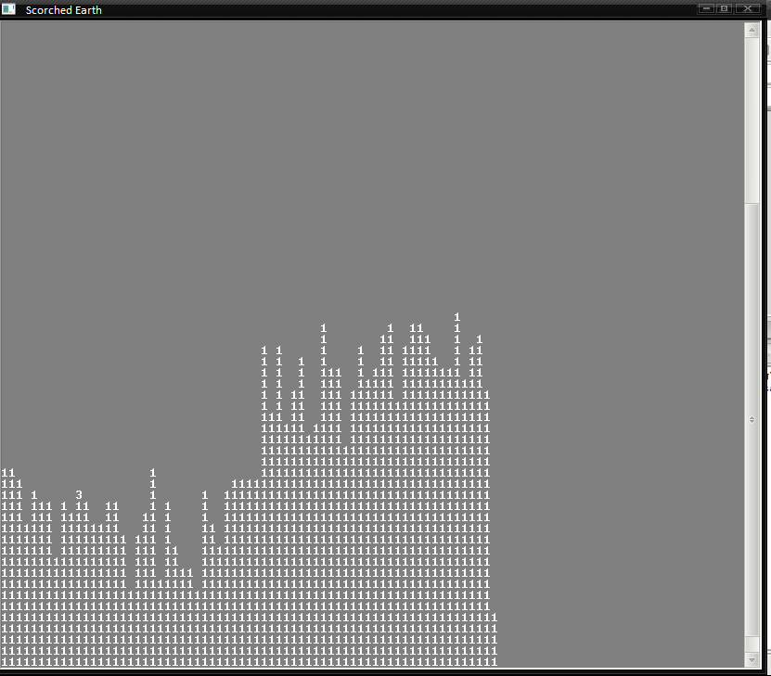

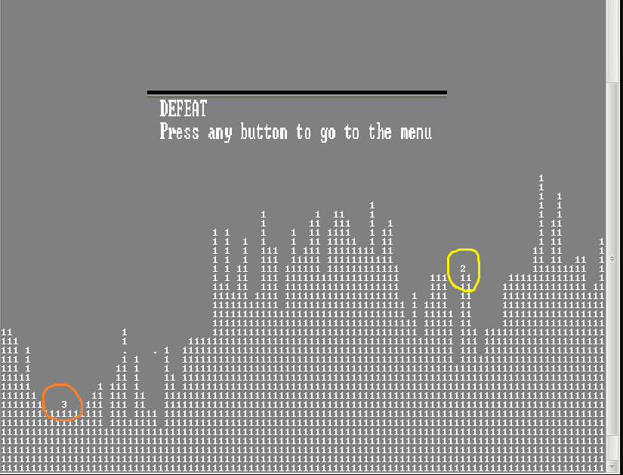

* When you play in the hard (or medium) mode, after one or two shoots the computer turns into easy mode and even kill itself.

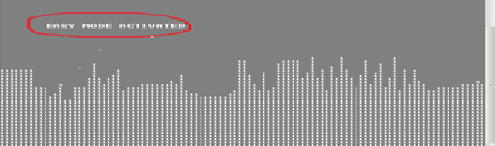

* If you put your power below 20, the player (number 3), disappears and never appears again until you fall as consequence of an enemy’s shot.

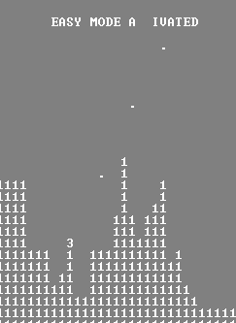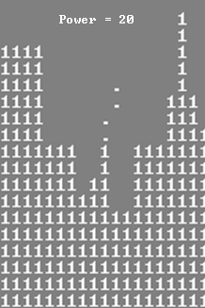

* After several defeats we tried to play in hard mode and it did not finished loading.



* In the option of the Menu to exit the game, if you put any character different than ‘y’ (in lower case) it goes back to the Menu and does not says that the input was invalid, so it never ask again if you want to get out or not.

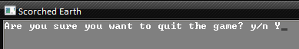

Not even with ‘Y’.

* If you are in the credits and press a key, it gets in the buffer:

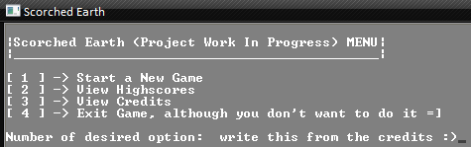

* If you fall from a hill of consequence of an enemy shot, your next shot will go out from your original position and not the actual position.
* The last error exists in the enemy too, so when you press SPACE the “Tower” appears in the middle of the air.
* The Tower just take damage if you hit it in the base and the shots do not came out from the “Eye”, they came out from the base of the tower.
* If you press ENTER while your shot is in the middle of the air or in the CPU’s turn, the “ENTER”s goes into the buffer, so your next shot will be triggered automatically like your last one.